Contents

LANGCHAIN (PLAGIARISM – 2%) 2

AN OVERVIEW OF LANGCHAIN MODULES: 3

WHAT ARE THE PRIMARY APPLICATIONS OF LANGCHAIN? 4

LANGCHAIN'S ADVANCED FEATURES AND CUSTOMIZATION OPTIONS 5

LANGCHAIN REFERENCES 6

CHATBOT (PLAGIARISM – 2%) 7

TWO MAIN TYPES OF CHATBOT 7

HOW DO CHATBOTS REVOLUTIONIZE YOUR BUSINESS? 8

HOW CAN CHATBOTS OPERATE WITHIN A BUSINESS? 8

BENEFITS OF CHATBOTS 8

THE FUTURE OF CHATBOTS 9

CHATBOT REFERENCES 9

LLM, LIKE CHATGPT API (PLAGIARISM – 6%) 11

LLM, LIKE CHATGPT API REFERENCES 14

PLAGIARISM CHECKER: https://www.duplichecker.com/ 14

Figure 1: An Overview of LangChain Modules 3

Figure 2: History of Chatbot 7

SUBMITTED BY: **ANISH THAPA**

# LANGCHAIN (PLAGIARISM – 2%)

LangChain is a Python library that enables the rapid development of applications powered by GPT, allowing us to create sophisticated language models in minutes. This comprehensive framework is intended to simplify interactions with large language model (LLM) providers such as OpenAI, Cohere, Bloom, Huggingface, and others. What sets LangChain apart is its unique ability to create Chains, which establish logical links between one or more LLMs. This distinctive feature greatly enhances the utility of LangChain.

By leveraging LangChain, we gain access to the following tools and functionalities, simplifying the development of LLM-powered applications:

* A flexible interface to many foundation models.
* A framework for effective management of prompts.
* A centralized interface for long-term memory, external data sources, other LLMs, and additional agents enables handling tasks beyond an LLM's capabilities (e.g., calculations or search operations).

LangChain proves to be a powerful tool for working with Large Language Models (LLMs). While LLMs excel at numerous tasks, their general nature may limit their ability to provide specific answers or tackle tasks requiring specialized domain knowledge or expertise.

Consider a scenario where an LLM is employed to answer questions related to a specific field, like medicine or law. Although the LLM can handle general inquiries about the field, it may struggle to provide detailed or nuanced responses that demand specialized knowledge.

The applications that can be developed using LangChain are both intriguing and diverse, spanning beyond the following examples:

* Chatbots
* Summarization and question-answering systems tailored for specific domains
* Apps capable of querying databases for information retrieval and subsequent processing
* Agents designed to solve specific problems, such as math and reasoning puzzles

## AN OVERVIEW OF LANGCHAIN MODULES:

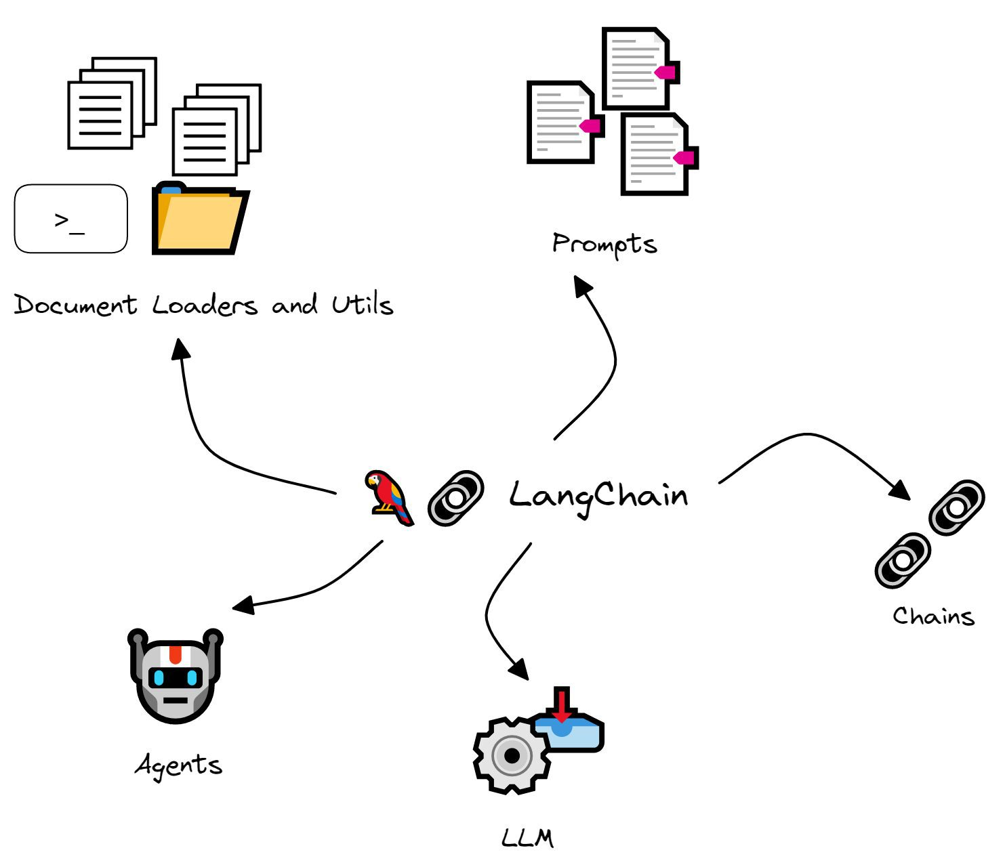

Figure 1: An Overview of LangChain Modules

1. **LLM (Large Language Model):**

The LLM serves as the fundamental component of LangChain. It acts as a wrapper around a large language model, enabling its functionality and capabilities to be utilized.

1. **Chains:**

Chains form the core of LangChain, serving as the essential backbone of its functionality. These logical connections between one or more LLMs can range from simple to complex, depending on the requirements and the involved LLMs. Let's delve deeper into both types:

a. Basic Chains:

Basic chains are the simplest form of chains that can be created. They involve a single LLM receiving an input prompt and generating text based on it.

b. Advanced Chains:

Advanced or utility chains involve multiple LLMs working together to tackle specific tasks. The SummarizeAndTranslateChain, emphasizing activities like summary and translation, is an instance of an advanced chain.

1. **The Role of Agents in LangChain:**

Agents within LangChain introduce an innovative way to call upon LLMs based on user input dynamically. They have access to an LLM and a suite of tools (such as Google Search, Python REPL, math calculators, weather APIs, etc.) that facilitate interaction with the external world.

1. **Prompts:**

Prompts lie at the core of any NLP(Natural Language Processing) application. Even in a ChatGPT session, the quality of the answer heavily depends on the prompt provided. LangChain addresses this by providing prompt templates that allow you to format inputs and a variety of additional utilities.

1. **Document Loaders and Utils:**

The Document Loaders and Utils modules in LangChain make it easier to connect to data sources and perform computations. These modules are particularly useful for applications that require direct interaction with underlying systems or situations where code snippets are needed to compute specific mathematical quantities or solve problems instead of computing answers in a one-time manner.

## WHAT ARE THE PRIMARY APPLICATIONS OF LANGCHAIN?

LangChain offers many applications where an LLM (Language Model) can be utilized effectively. Let's explore several examples:

* **Document Summarization**

Harness the power of LangChain's Data Augmented Generation to connect with external data sources and condense lengthy texts into concise summaries, enabling users to grasp essential information easily.

* **Tailored Question Answering**

Construct a question-answering system to search specific documents or databases, delivering precise answers to users' inquiries.

* **Intelligent Chatbots**

Develop chatbots that can comprehend and respond to user inputs, creating a more interactive and engaging conversational experience.

* **Virtual Assistants**

Build virtual assistants capable of performing various tasks, such as scheduling appointments, managing to-do lists, and providing personalized recommendations.

* **Language Translation**

Utilize LangChain to create an application that seamlessly translates text between different languages, breaking down language barriers and facilitating effective communication.

* **Sentiment Analysis**

Analyze user-generated content, such as product reviews or social media posts, to determine the sentiment behind the text, aiding businesses in understanding customer feedback.

* **Content Generation**

Develop an application to generate creative content based on user inputs or specific topics, including blog posts, social media captions, or poetry.

* **Code Completion**

Create an intelligent code completion tool that assists developers in writing code more efficiently by suggesting relevant code snippets based on the current context.

* **Personalized Learning**

Build a learning platform to identify user knowledge gaps and generate customized content to enhance learning and growth.

* **Collaborative Filtering**

Develop a recommendation system leveraging LangChain's memory capabilities to provide users with personalized suggestions based on their preferences and browsing history.

## LANGCHAIN'S ADVANCED FEATURES AND CUSTOMIZATION OPTIONS

LangChain goes beyond traditional language models with its advanced features and customization possibilities, enabling the creation of powerful applications. Some notable features include:

* **Customizable Prompts**

Tailor your application's prompts to align with your specific requirements and optimize performance.

* **Building Chain Link Components**

Construct chain link components to achieve advanced functionalities and cater to complex use cases, such as Generative Question-Answering (GQA) or chatbots.

* **Code Customization**

Customize the code to develop unique applications and unlock the full potential of LangChain.

* **Model Integration**

Integrate LangChain with data-augmented generation and gain access to high-quality language model applications like text-davinci-003 for improved performance.

* **Flexible Component Options**

Mix and match components to fulfil specific requirements and create a customized application that meets your needs.

* **Context Manipulation**

Manipulate and guide context to improve accuracy and enhance user experience.

With LangChain's advanced customization options, you can create feature-rich applications that set you apart.

### LANGCHAIN REFERENCES

Avra (2023) *Getting started with Langchain  - a powerful tool for working with large language models*, *Medium*. Available at: https://medium.com/databutton/getting-started-with-langchain-a-powerful-tool-for-working-with-large-language-models-286419ba0842 (Accessed: May 31 2023).

CodeWithYaku (2023) *Unleash the power of Langchain 🦜️🔗: 10 cool use cases you can build.*, *DEV Community*. Available at: https://dev.to/codewithyaku/unleash-the-power-of-langchain-10-cool-use-cases-you-can-build-12bo (Accessed: May 31 2023).

Experts, E.D. (2023) *What is Langchain? A beginner's guide with examples*, *Master Data & AI Skills*. Available at: https://blog.enterprisedna.co/what-is-langchain-a-beginners-guide-with-examples/ (Accessed: May 31 2023).

*Langchain: Introduction and getting started* (no date) *Pinecone*. Available at: https://www.pinecone.io/learn/langchain-intro/ (Accessed: May 31 2023).

Learning Actors (2023) *Langchain 101: Build your GPT-powered applications*, *Learning Actors*. Available at: https://learningactors.com/langchain-101-build-your-own-gpt-powered-applications/ (Accessed: May 31 2023).

Monigatti, L. (2023) *Getting started with Langchain: A beginner's guide to building LLM-Powered Applications*, *Medium*. Available at: https://towardsdatascience.com/getting-started-with-langchain-a-beginners-guide-to-building-llm-powered-applications-95fc8898732c (Accessed: May 31 2023).

Sakamoto, N. (no date) *Explained: What is Langchain? How to use Langchain Chains?*, *Kanaries*. Available at: https://docs.kanaries.net/articles/langchain-chains-what-is-langchain (Accessed: May 31 2023).

*Welcome to Langchain* (2023) *Welcome to LangChain - 🦜🔗 LangChain 0.0.186*. Available at: https://python.langchain.com/en/latest/index.html#use-cases (Accessed: May 31 2023).

# CHATBOT (PLAGIARISM – 2%)

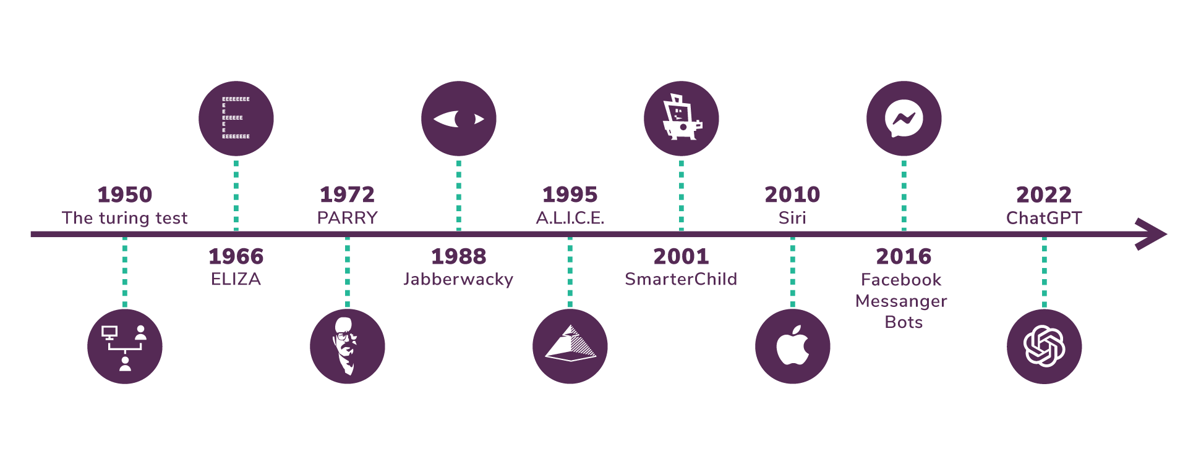

Figure 2: History of Chatbot

Chatbots, also known as "conversational agents," are software applications that imitate human speech, whether written or spoken, to simulate conversations or interactions with real individuals.

A chatbot is computer software that understands client questions and automates responses, simulating human conversation. By responding to questions and requests through text or audio input, or a combination of both, chatbots facilitate users in finding the information they need without requiring human intervention.

Chatbots excel at handling straightforward, frequently asked questions. However, they typically struggle with complex, multipart questions that a human support agent can handle unless their underlying technology is highly sophisticated.

## TWO MAIN TYPES OF CHATBOT

Chatbots process data to reply to multiple queries using AI, automated standards, natural language processing (NLP), and machine learning (ML). There are two primary types:

1. **Task-oriented (declarative) chatbots:**

These are single-purpose programs designed to perform specific functions. They generate automated yet conversational responses to user inquiries using rules, NLP, and minimal ML. Task-oriented chatbot interactions are extremely specific and ordered, making them ideal for customer service and support roles.

Think of them as full, interactive FAQs. These chatbots can handle common questions, such as queries about business hours or simple transactions with limited variables. Currently, task-oriented chatbots are the most commonly utilized.

1. **Data-driven and predictive (conversational) chatbots:**

These chatbots are often called virtual or digital assistants, which are much more sophisticated, interactive, and personalized than their task-oriented counterparts. They possess contextual awareness and leverage natural language understanding (NLU), NLP, and ML to learn continuously. They apply predictive intelligence and analytics to provide personalized experiences based on user profiles and past behaviours.

Digital assistants can learn user preferences over time, offer recommendations, and anticipate needs. They can initiate dialogues in addition to analyzing data and intent. Consumer-oriented, data-driven, predictive chatbots like Apple's Siri and Amazon's Alexa exemplify this category.

## HOW DO CHATBOTS REVOLUTIONIZE YOUR BUSINESS?

Chatbots represent a one-time investment that offers instant self-service, deflects many inquiries, and can easily scale according to our requirements. If you're considering implementing chatbots for your business, here are a couple of reasons to get started:

**Improved client satisfaction**: Chatbots can offer frictionless help by answering inquiries precisely and directing clients in the proper direction. Intelligent chatbots can provide contextual guidance and escalate discussions to a human representative when appropriate.

Other ways companies leverage chatbot technology:

* **Automating website support**: Businesses use chatbot automation capabilities to provide 24/7 customer service on their websites. Chatbots can offer more information about services and items and answer basic questions anytime and from any location.
* **Site navigation**: Chatbots assist customers in navigating websites and provide instructions for tasks like signing up for a service or free trial.
* **Personalized suggestions**: Chatbots can provide personalized recommendations by studying client activity on a website.
* **Order tracking and inventory management**: Chatbots can inform customers about product availability and estimate shipping time.
* **Increasing sales**: Chatbots such as Answer Bot can direct users to help centre pages by addressing inquiries about items or services before they abandon shopping carts.

## HOW CAN CHATBOTS OPERATE WITHIN A BUSINESS?

Chatbots utilize predefined conversation flows, natural language processing, and machine learning to answer questions and guide users through various scenarios, such as:

* Resolving login issues
* Assisting with payment problems
* Providing booking instructions
* AI-powered bots can also learn from each interaction and adapt their actions to offer improved support.

## BENEFITS OF CHATBOTS

We've already discussed how chatbots improve customer experience, but that's not their only advantage. Organizations can enjoy numerous benefits by using chatbots for business growth, process efficiency, and cost reduction.

* **Cost-effectiveness**: Chatbots are a one-time investment. Once developed and implemented, they eliminate the need to hire additional customer support staff. Instead, human resources can focus on solving complex problems and devising strategies for business growth. Unlike human agents, chatbots do not make mistakes in established processes.
* **Time-saving**: Chatbots handle routine, repetitive tasks much faster than humans.
* **24/7 availability**: Chatbots can be accessible to customers round the clock without significant effort. It can make more satisfied customers likely to recommend your products or services to others.
* **Minimized customer wait time**: Because each chatbot may interact with numerous clients simultaneously, wait times are reduced. Customers can receive real-time answers to their queries when engaging with chatbots.
* **Lead identification**: AI chatbots excel at identifying patterns and keywords. As they handle initial support interactions with customers or prospects, they can be programmed to identify leads by listening to customers' words and phrases.

## THE FUTURE OF CHATBOTS

What lies ahead for the evolution of chatbots? Like other AI tools, chatbots will further enhance human capabilities and allow humans to focus on more creative and innovative tasks, spending our time on strategic activities rather than tactical ones.

Soon, when AI combines with the development of 5G technology, businesses, employees, and consumers can expect enhanced chatbot features such as faster recommendations and predictions and easy access to high-definition video conferencing within a conversation. These possibilities, among others, are currently in the research stage and will evolve rapidly as internet connectivity, AI, NLP, and ML advance. Ultimately, each individual may have a fully functional personal assistant in their pocket, making our world a more efficient and interconnected place to live and work.

### CHATBOT REFERENCES

*Chatbot 101: Ultimate Guide to Transform Your Customer Experience* (no date) *Chatbot 101: Ultimate Guide to Transform Your Customer Experience*. Available at: https://www.boost.ai/chatbot (Accessed: May 31 2023).

Hoffman, M. and Operations, D. of C. (2023) *What is a chatbot + how does it work?*, *Zendesk*. Available at: https://www.zendesk.com/blog/chatbots-for-business/ (Accessed: May 31 2023).

Shewan, D. (2023) *10 of the most innovative chatbots on the web*, *WordStream*. Available at: https://www.wordstream.com/blog/ws/chatbots (Accessed: May 31 2023).

Shweta (2023) *What is a chatbot? Everything you need to know*, *Forbes*. Available at: https://www.forbes.com/advisor/business/software/what-is-a-chatbot/ (Accessed: May 31 2023).

Staff, E. (2023) *What is a chatbot? Here's everything to know*, *Entrepreneur*. Available at: https://www.entrepreneur.com/science-technology/what-is-a-chatbot-heres-everything-to-know/445021 (Accessed: May 31 2023).

*What is a chatbot?* (no date a) *IBM*. Available at: https://www.ibm.com/topics/chatbots (Accessed: May 31 2023).

*What is a chatbot?* (no date b) *Oracle*. Available at: https://www.oracle.com/chatbots/what-is-a-chatbot/ (Accessed: May 31 2023).

*What is a chatbot? A guide on AI Chatbots (2023) - fresh chat* *Freshworks*. Available at: https://www.freshworks.com/live-chat-software/chatbots/what-is-a-chatbot/ (Accessed: May 31 2023).

# LLM, LIKE CHATGPT API (PLAGIARISM – 6%)

Large language models possess immense power, although they may not excel in every task. Instead of providing direct answers, a large language model (LLM) can employ various steps to gather the necessary information by incorporating plugins or tools. These plugins extend language models' abilities, making them more adaptable and capable of handling various jobs.

The world has witnessed the incredible popularity of ChatGPT, an internet sensation. It is built on OpenAI's GPT-3 language model, enabling users to engage in conversations with AI by entering prompts. However, the recent launch of GPT-4 has taken ChatGPT to new heights, granting the bot even more power.

With the introduction of ChatGPT plugins, users can now leverage additional capabilities, such as accessing up-to-date information from public or private sources, executing code for complex calculations or data processing tasks, and integrating with third-party services to performing tasks on other platforms seamlessly without leaving the chat interface. These plugins expand the possibilities of language models, allowing them to perform diverse functions, from creating Jira tickets to adding items to online shopping carts or retrieving real-time sales data from Salesforce.

Other AI models can help scholars, programmers, and small businesses create language-based solutions and compete with industrial giants. While the performance of these models may not surpass that of existing ones, with time and community contributions, some alternatives can potentially exceed expectations.

Let's take a look at a few of these alternative AI models:

1. OPT by Meta

Meta released a robust GPT-3 open-source alternative called Open Pretrained Transformer language model (OPT) in May 2022. OPT boasts 175 billion parameters and combines pre-trained models with their source code for utilization and training purposes. It is available solely for research purposes under a non-commercial license, aiming to empower educational, governmental, civil institutions, and industry research laboratories to delve deeper into the technology and explore its ethical applications.

1. AlexaTM by Amazon

Amazon introduced AlexaTM 20B, a large-scale multilingual sequence-to-sequence model, on November 18, 2022. This model utilized an encoder-decoder architecture and was trained on causal-language modelling (CLM) and denoising tasks. AlexaTM outperforms decoder-only models as a few-shot learner, excelling in tasks like 1-shot summarization and machine translation, surpassing Google's PaLM 540B. Additionally, the model supports multiple languages, making it a noteworthy competitor among all LLMs, regardless of their pricing model.

1. CodeGen by Salesforce

CodeGen is another open-source alternative to GPT-3 that generates programs based on simple textual prompts. It is based on the idea of conversational AI, which promises to combine human creative input alongside the boundless powers of AI code.

One remarkable aspect of CodeGen is its accessibility, allowing even individuals without a technical background to utilize it. However, programming knowledge can enhance the quality and elegance of the generated solutions, as AI is not yet perfect.

1. LaMDA by Google

LaMDA stands for autoregressive Language Model for Dialog Applications and features a decoder-only architecture. In addition to chit-chat on various topics, LaMDA can create lists and be trained to converse about domain-specific subjects. Dialogue models excel in scaling and handling long-term dependencies, enabling them to consider the current input and the previous context. Furthermore, these models support domain grounding, enhancing their conversational capabilities.

1. BLOOM

BLOOM is an autoregressive LLM developed as an alternative through the BigScience Workshop, involving the collaboration of over 1000 AI researchers, including specialists from Microsoft, NVIDIA, PyTorch, and others. BLOOM is available to any individual or research team interested in studying the performance and behaviour of large language models, provided they agree with the model's licensing terms.

1. BERT by Google

BERT (Bidirectional Encoder Representations from Transformers) is one of the earliest transformer language models, released as an open-source project in 2018 and pre-trained on Wikipedia texts. Since 2019, Google has utilized BERT to improve search intent understanding and offer more relevant query predictions. As a bidirectional unsupervised language representation model, BERT considers both the previous context and the subsequent conditions to continue a sentence.

1. Chinchilla by DeepMind

Chinchilla, introduced in March 2022 by DeepMind, an AI lab acquired by Google in 2014, is a compute-optimal language model. Despite being only 70 billion parameters, Chinchilla was trained on a massive dataset of 1.4 trillion tokens, four times more extensive than most popular LLMs.

1. Flan-T5-XXL

Flan-T5-XXL represents fine-tuned T5 models trained on a vast collection of instructional datasets. This fine-tuning approach significantly improves performance across various model classes, such as PaLM, T5, and U-PaLM. Additionally, the Flan-T5-XXL model underwent fine-tuning for over 1000 additional tasks in multiple languages, broadening its capabilities.

1. Poe

Poe presents a multitude of options as an alternative to ChatGPT. This app, developed by Quora, the renowned question-and-answer website, combines seven AI chatbots within a single user interface.

1. Chatsonic

Chatsonic stands out as the most potent alternative to ChatGPT in the current market. It seamlessly integrates with Google, enabling the generation of factual responses using real-time data. Moreover, it possesses the capability to receive voice commands and provide voice responses, making it an incredibly versatile and user-friendly tool. Notably, Chatsonic offers unique features, such as the ability to create AI art and interact with a personalized avatar. It also has the functionality to remember past conversations, allowing users to edit, share, and download them for future reference.

1. Jasper

Jasper, previously known as Jarvis, is among the top AI writing tools available. It encompasses authoring services such as Headline and Shortly AI, both standalone solutions but aim to achieve complete integration with Jasper. By selecting a subject and providing the relevant data through a form, Jasper generates content on your behalf.

1. Socratic

Socratic, developed by the dominant search engine Google, is an exceptional tool for assisting students with academic work. Using artificial intelligence, this software swiftly solves math problems or chemical reactions. Scan the problem with the Socratic app, and Google's AI will respond within seconds.

1. YouChat

YouChat functions as a search engine, presenting a list of indexed web pages relevant to your query and a chatbot offering conversational responses akin to ChatGPT. If you desire a product that combines the functionalities of a search engine and a chatbot, YouChat is an excellent choice.

1. GitHub Copilot X

GitHub Copilot X addresses programmers' frustrations, serving as a comprehensive solution. Based on the concept of auto-completion, Copilot goes beyond that by suggesting and completing code snippets and even entire functions in real time. It acts as a helpful tool to overcome programming obstacles.

GitHub has recently introduced chat and voice capabilities for Copilot, offering users an experience similar to ChatGPT. Developers can use GitHub Copilot Voice to offer natural language prompts vocally. Simply asking Copilot X for code improvements will promptly suggest relevant suggestions. Additionally, Copilot X can assist with AI-powered tags, provide in-depth analysis and explanations of code blocks using the power of GPT-4, support pull requests, answer documentation-related questions, and deliver a personalized developer experience.

1. GPT4all

GPT4all is a community-driven project trained on an extensive collection of curated written texts, encompassing assistant interactions, code, stories, descriptions, and multi-turn dialogues. The project team made data sets, data curation techniques, model weights, and training code public to promote an open-source model.

Furthermore, a 4-bit model version has been released, which requires less memory and computational power, enabling it to run on standard laptops. Additionally, a Python client is provided for easy interaction with the model.

1. ColossalChat

ColossalChat is an open-source project which enables AI models to be cloned using a full RLHF (Reinforcement Learning from Human Feedback) pipeline. This comprehensive project encompasses a bilingual dataset, training code, a demonstration, and 4-bit quantized inference. These components collectively empower users to create customized chatbots in a more cost-effective and time-efficient manner.

### LLM, LIKE CHATGPT API REFERENCES

Awan, A.A. (2023) *Chatgpt and GPT-4 open source alternatives balancing the scales*, *DataCamp*. Available at: https://www.datacamp.com/blog/12-gpt4-open-source-alternatives (Accessed: May 31 2023).

Ingle, P. (2023) *Top CHATGPT alternatives you can use in 2023*, *MarkTechPost*. Available at: https://www.marktechpost.com/2022/12/16/top-chatgpt-alternatives-that-you-can-use-in-2023/ (Accessed: May 31 2023).

McMillan, M. (2023) *7 best CHATGPT alternatives I’ve tested*, *Tom’s Guide*. Available at: https://www.tomsguide.com/features/chatgpt-alternatives (Accessed: May 31 2023).

Mugayi, T. (2023) *List of open source alternatives to chatgpt that can be used to build your clone*, *Medium*. Available at: https://betterprogramming.pub/list-of-open-source-alternatives-to-chatgpt-that-can-be-used-to-build-your-own-clone-f45efb978ad9 (Accessed: May 31 2023).

Sharma, U. (2023) *16 best CHATGPT alternatives in 2023 (free and paid)*, *Beebom*. Available at: https://beebom.com/best-chatgpt-alternatives/ (Accessed: May 31 2023).

Team, A. expert (2023) *Top 9 open-source GPT-3 Alternative Solutions*, *Altamira*. Available at: https://www.altamira.ai/blog/open-source-gpt-alternative-solutions/ (Accessed: May 31 2023).

Timothy, M. (2023) *The 6 best alternatives to a chatbot*, *MUO*. Available at: https://www.makeuseof.com/best-alternatives-chatgpt/ (Accessed: May 31 2023).

Vivek, S. (2023) *LLM Economics: Chatgpt VS open-source*, *Medium*. Available at: https://towardsdatascience.com/llm-economics-chatgpt-vs-open-source-dfc29f69fec1 (Accessed: May 31 2023).

Vleeshouwer, M. (2023) *How do CHATGPT plugins (and similar LLM Concepts) work?*, *Medium*. Available at: https://medium.com/@imicknl/how-do-chatgpt-plugins-and-similar-llm-concepts-work-2c83a4aeedd4 (Accessed: May 31 2023).

### PLAGIARISM CHECKER: <https://www.duplichecker.com/>